INTRODUNCTION TO NETWORKS

Q1. Draw a simple diagram (hand-drawn or digital) showing how your phone connects to Instagram, including your device, Wi-Fi router, ISP, and Instagram server. Label each part and the connections.
Ans.
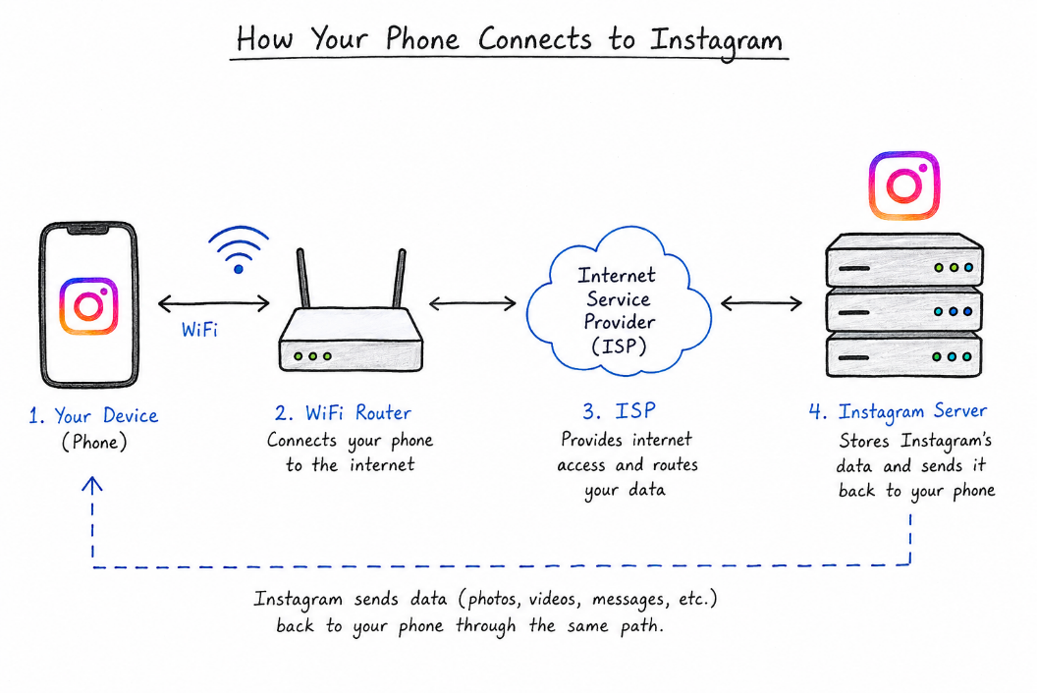
Q2. List 5 devices you use or see daily that are part of a network (for example: smartphone, smart TV, Wi-Fi router, laptop, smartwatch). For each, write what type of network it connects to (LAN, WAN, PAN, etc.)
Ans.
Device | Type of Network | How it Connects
Smartphone | WAN / PAN | Uses mobile data for WAN and Bluetooth for PAN.
Laptop | LAN | Connects to a home or school Wi-Fi network.
Wi-Fi Router | LAN / WAN | Connects local devices through LAN and connects them to the Internet through WAN.
Smart TV | LAN | Connects to the Wi-Fi router to access the Internet.
Smartwatch | PAN | Connects to a smartphone using Bluetooth over a short distance.

Q3. Explain the difference between the Internet and an intranet using an example from your college or a public Wi-Fi you have used.
Ans. The Internet is a public network that anyone can use. For example, using college Wi-Fi to open Google or YouTube means using the Internet.
An intranet is a private network used only by people in a college or company. For example, a college student portal for attendance, notes, or notices can be an intranet.
Internet = public network
Intranet = private network
Q4. Pick any one app you use (like WhatsApp, Zomato, or Flipkart) and describe, in 4-5 lines, how data travels from your device to their server and back when you perform a search inside the app. Hint: Mention the devices and networks involved, and what happens when you hit 'search'.
Ans. Example: Flipkart
- When I search for a product on Flipkart, my phone sends the search request through Wi-Fi or mobile data.
- The request travels through the Internet to Flipkart’s server.
- The server finds the products related to my search.
- It sends the results back through the Internet to my phone.
- Then the Flipkart app shows the products on my screen.

